Defining Classes Labs – Part 2

This is an individual lab.

Read the attached Defining classes lab.

Your tasks:

1. Update your class diagram with any changes noted in your previous lab. Your class diagram must support the case study and Systems Use Case Specifications

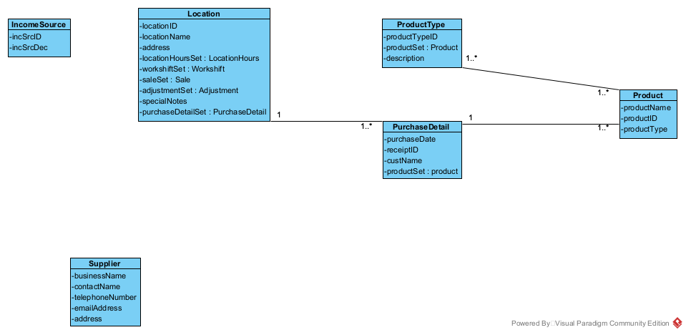

1. Create Object Level sequence diagrams for the remaining specifications.

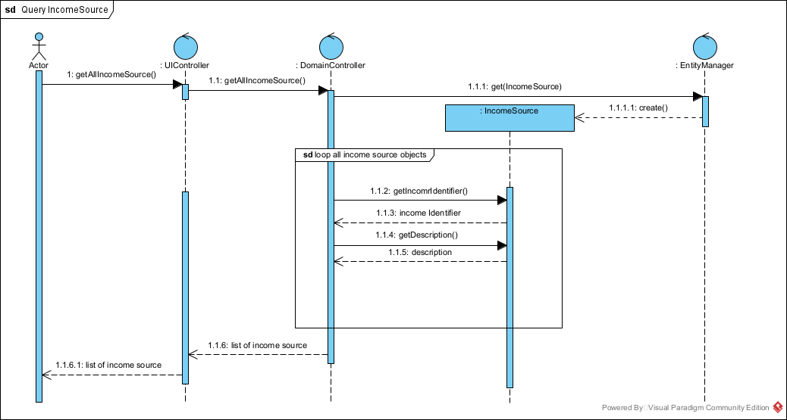

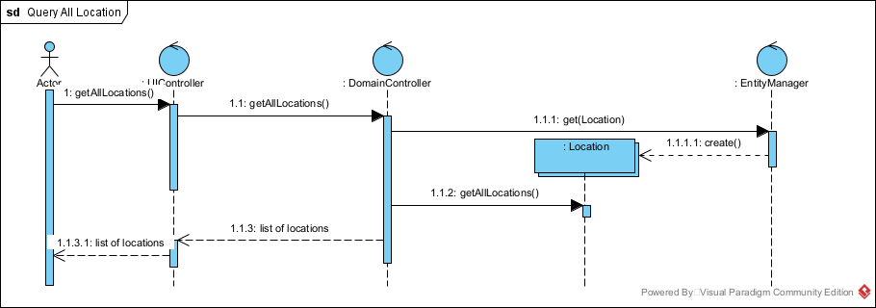

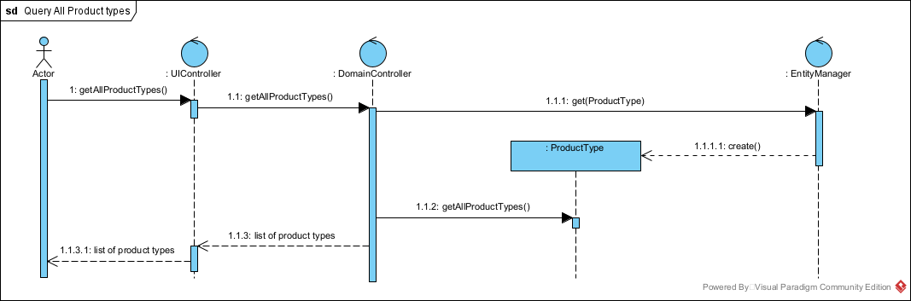

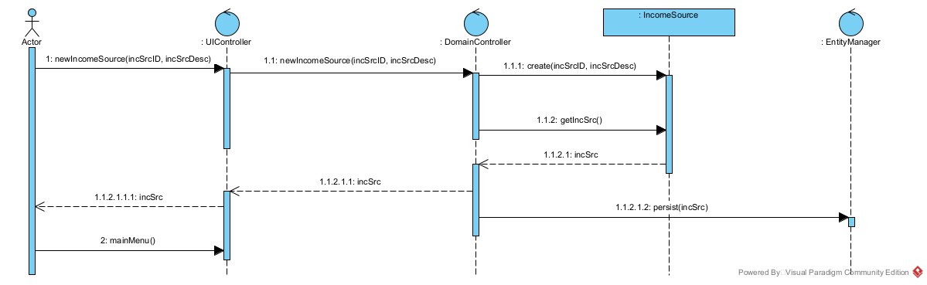

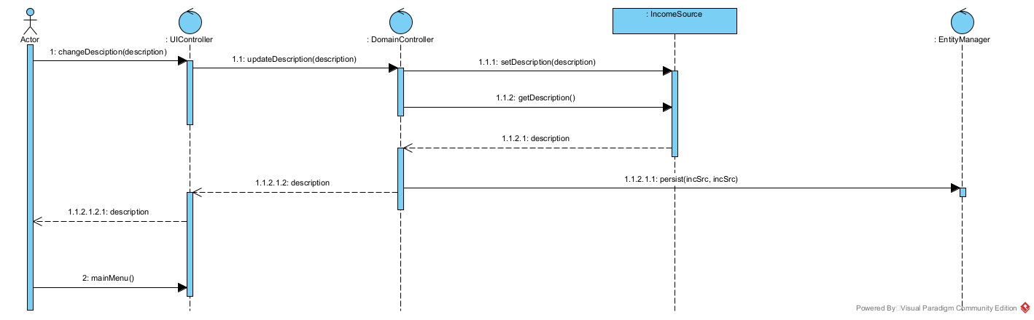

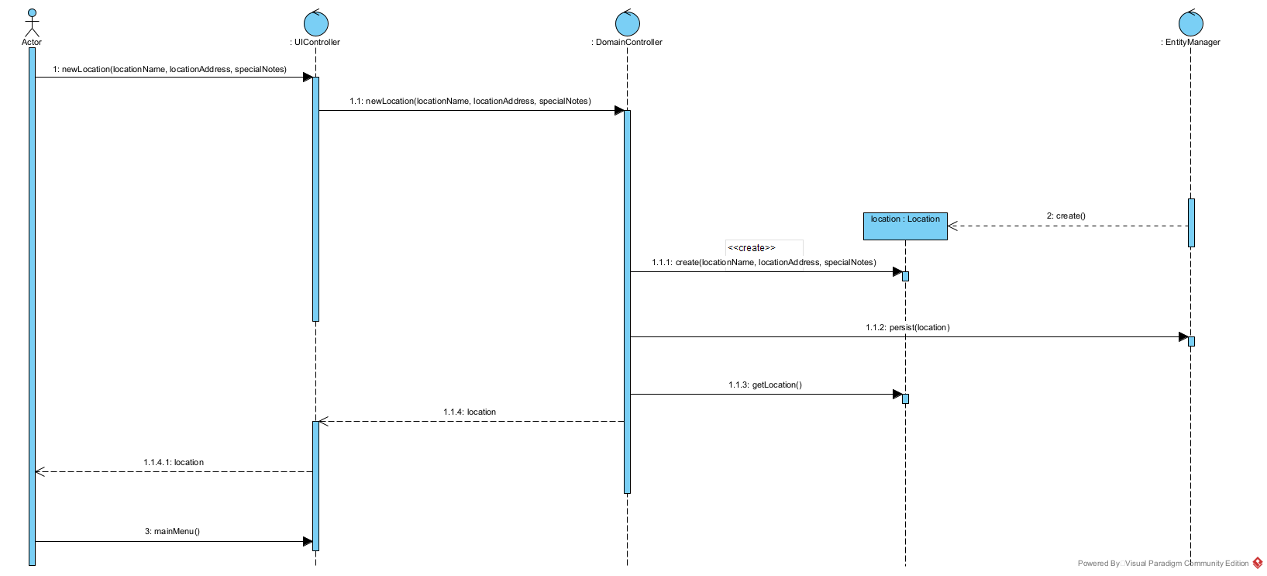

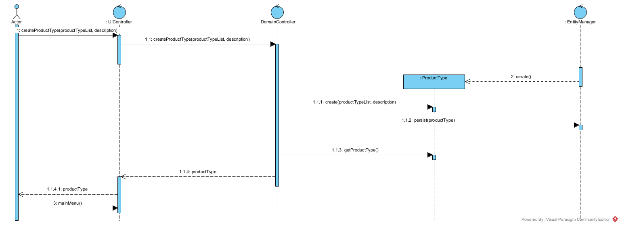

1. A supplier has the following information:
   1. Business Name
   2. Contact Name
   3. Telephone number
   4. Email address
   5. Address
   6. Identifier

Using the examples, try writing a User Story and a scenario for Create Supplier. Add the supplier class to your class diagram and create an object level sequence diagram to support your work

User Story.

We would like to record the supplier detail.

Acceptance Criteria:

1. Must be able to record all suppliers.
2. Must be able to query all suppliers.

|  |  |
| --- | --- |
| Uses Case Name | Create a supplier |
| Triggering Event | A new supplier |
| Brief Description | Owner |
| Related Uses Cases |  |
| Preconditions | Owner has opened the Main Menu |
| Flow of activities | |  |  |  | | --- | --- | --- | | Actor | | System | | 1 | Requests to add a new supplier | Displays a list of supplier and prompts for a supplier name, telephone, etc. | | 4 | Enter the supplier name, telephone, etc. | Verifies that name and telephone have been enter. Generates a unique supplier identifier. Displays supplier. Prompts for confirmation. | | 5 | Confirms entry | Save the supplier and return to the main Menu | |
| Exception Conditions | Owner choose to cancel adding the supplier. |

|  |  |
| --- | --- |
| Uses Case Name | Query all supplier |
| Triggering Event | Request for all supplier |
| Brief Description | Owner |
| Related Uses Cases |  |
| Preconditions | Owner has opened the Main Menu |
| Post Conditions | All suppliers are retrieved |
| Flow of activities | |  |  |  | | --- | --- | --- | | Actor | | System | | 1 | Request to query all suppliers | Display a list of Suppliers | | 4 | Chooses to cancel | Return to the main menu. | |
| Exception Conditions | Owner chooses to cancel query suppliers. |

